# Kinley Wangmo – Compassionate Certified Caregiver

## A person with black hair and a striped shirt AI-generated content may be incorrect.About Me

I am a hardworking, skilled, and compassionate caregiver trained at Sprott College in British Columbia with hands-on experience in local care homes. As the eldest child raised by a single mother, caregiving is second nature to me. Canada has given me a home; now I hope to give back by caring for your family.

|  |  |
| --- | --- |
| Qualifications | Experience |
| * Certified Health Care Assistant * First Aid and CPR-C * Medication Assistance Course * Acute Care Settings | * Inglewood Care Center * Weinberg Assisted Living * Caring Sheppard |

## What I Offer

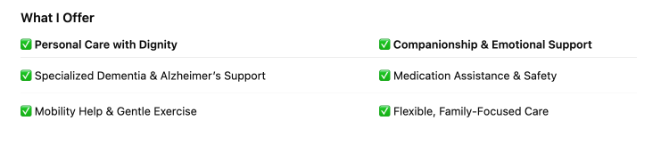

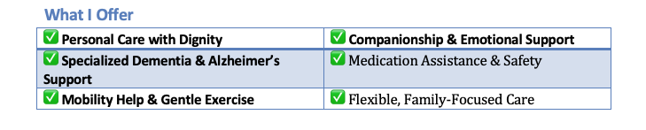

|  |  |
| --- | --- |
| Personal Care (bathing. dressing, denture care) | Companionship and emotional support |
| Assistance with daily activities (meal prep, feeding,house keeping, shopping…) | Help with mobility and exercise |
| Support for dementia, Alzheimers, memory care | Medication assistance and administration |
| Monitoring vital signs and health conditions | Managing anxiety, insomnia and challenging behaviors |
| Support for chronic conditions: (diabetes, Parkinsons, UTIs, dysphagia, sensory impairments | Infection control and safe practices |
| Flexible schedule -family focused care |  |

## Hiring Me Is Easier Than You Think

– The Canadian government allows private households to hire caregivers legally.  
– A licensed consultant will help with all paperwork.  
– Your cost is mainly wages plus a one-time $1,000 government LMIA fee.  
– I am already in Canada and ready to work as soon as my work permit is approved.

## Contact Kinley

Phone: 236-867-9389

Email: [kingallet2001@gmail.com](mailto:kingallet2001@gmail.com)

In-depth information about my background and qualifications and the LMIA procedure: httpskinleyw.ca

References available upon request.

-----------------

Website:

* Caregiver Profile (above material)
* Personal story
* More information about background and experience
* LMIA procedure as well as a link to the template.

-----------------------

Personal Story

I was raised in Bhutan by a single mother who worked tirelessly as a gardener to give me and my siblings an education. She sacrificed everything to keep our family strong, even while being looked down upon for raising four children alone. As the eldest, I grew up caring for my younger siblings and grandparents — caregiving became second nature to me.

Life was not easy. As a child, I often stayed with my uncle because my mother couldn’t manage all four of us at once. Though he was kind, I often went to bed with an empty stomach, unsure if I would get enough to eat, feeling small and invisible in a world that seemed too big for me. At five, I went to live with my father, where my stepmother mistreated me. From a very young age I learned to cook, clean, wash clothes, and dress myself. Those early hardships made me hardworking, resilient, and determined to study and build a better future.

During the COVID pandemic, I met my husband through social media, and he quickly became my greatest source of strength. His own life had been full of struggles — he grew up without the right education due to an abusive stepfather, and in 2024, he lost his beloved mother to cancer. Despite his own pain, he never gave up. He worked as a chef and supported me emotionally and financially while I prepared to come to Canada. After we arrived, he took on two jobs to pay my school fees, rent, and living expenses. On his days off, he would join me in cleaning jobs, and he always made sure I had healthy meals to eat. He is hardworking, honest, and innocent at heart — a man whose love makes me feel the safety and care I once longed for from my own father. I feel so lucky to have him by my side.

Coming to Canada was my dream, but it wasn’t easy. My mother took loans so my husband and I could make this journey. After we arrived, I was blessed with the kindness of Tina, Tiara, and Tiara’s parents, who supported me with my studies and gave me hope when I needed it the most. Tiara even rented me her basement room at a lower rent, and living close to them feels like having a family again. Whenever I need a shoulder to cry on, someone to share with, or advice to guide me, I find it in them.

Canada has given me more than anyone ever could — when Tina noticed my dedication while I was cleaning Airbnb homes, it was the first time I felt seen and valued. That moment changed the course of my life, giving me hope and a sense of belonging.

Through my journey, I have learned some of life’s most important lessons:

* **Kindness has the power to change lives.** Even the smallest act of compassion can give someone hope when they feel like giving up.
* **Hardship builds strength.** The struggles of my childhood taught me resilience, independence, and determination.
* **Family is not only by blood.** The love and support I received from people like Tina, Tiara, and her parents made me realize that family is built from trust, care, and shared humanity.

I carry these lessons with me every day. My dream is to stand on my own feet, become independent, and build a stable future. As a foreigner in Canada, it is expensive to attend school and pursue higher education. I’m deeply grateful to Tiara for organizing a GoFundMe project to cover my tuition fees and to everyone who contributed. Their generosity — along with the unwavering support of my husband — made my dream possible.

Now, I want to carry that kindness forward through my work as a caregiver, offering compassion, dignity, and respect to Canadian families. If you provide me with an LMIA and hire me to care for your loved one, I will ensure they receive the highest quality care. I am hardworking, dependable, and maintain a positive attitude. Caring for the elderly reminds me of the love I shared with my mother and grandparents, and every smile I bring to someone’s face feels like a piece of the home and family I missed as a child.

**If you trust me with your loved one, I will care for them as my own — with comfort, dignity, and joy. In doing so, I will continue the journey of gratitude and love that brought me here.**

---------------------

Title for the page: ??

### My Training & Credentials

I completed the Health Care Assistant Program at Sprott Shaw College, Vancouver, where I trained in both classroom and clinical settings.

Certifications:

* Certified Health Care Assistant (BC Care Registry)
* First Aid & CPR-C with AED
* Food Safe Level 1
* WHMIS
* Crisis Prevention (CPI)
* Medication Assistance Course
* Care in Acute Care Setting
* Respirator Fit Test

Clinical Experience:

* Inglewood Care Centre – Multi-level and complex care (personal care, lifts, feeding, emotional support)
* Weinberg Assisted Living – Assisted living and home support (ADLs, companionship, meal service, respecting privacy and dignity)
* Caring Shepherd – Currently working as a Health Care Assistant as part of my internship, providing in-home and care centre support. This gave me 6 months of hands-on Canadian experience, including personal care, mobility assistance, medication reminders, and collaboration with families and nurses.

Work Experience:

* Caring Shepherd (Vancouver, BC) – Currently working as a Health Care Assistant as part of my internship. Provides in-home and care centre support, including personal care, mobility assistance, medication reminders, and collaboration with families and nurses.
* Independent Airbnb Cleaner (Vancouver, BC) – Provides Airbnb cleaning, move-out cleaning, office cleaning, and general residential cleaning. Developed strong time management, attention to detail, and reliability while balancing work and study.
* Personal Support Worker (Bhutan) – Assisted with meals, medication reminders, personal care, and companionship, developing multitasking, empathy, and communication skills.

### What I Offer

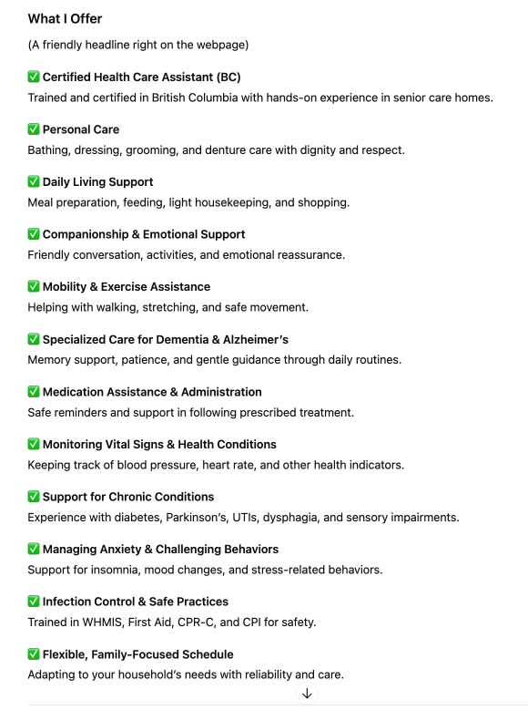

### What I’m Looking For

I am seeking an employer who can provide an LMIA (Labour Market Impact Assessment) so I can continue working legally in Canada. While the LMIA/work permit is being processed, I am ready to start immediately as a volunteer.

Here’s what it means for you:

* You can legally hire me as your caregiver.
* I can handle paperwork with the help of my immigration consultant:
  + Mr. Justin Shim
  + Email: Justin.shim@cannestimm.com
  + Phone: 604-662-3266 / 236-521-5105
  + Company: CanNest Immigration Consulting
  + Address: 1308-1030 West Georgia St, Vancouver, BC, V6E2Y3
* Your main cost is my wages plus the one-time government LMIA fee of $1,000.

My Commitment and Closing Statement

If you provide me with an LMIA and hire me to care for your loved one, I will ensure they receive the happiest, highest-quality care. I am hardworking, dependable, and maintain a positive attitude. Caring for the elderly makes me feel connected to my own mother and grandparents, and it gives me deep satisfaction and purpose.

I will make sure you never regret hiring or helping me. I value loyalty, gratitude, and trust, and I will bring those qualities into the care of your loved one every single day.

I truly hope to meet you soon. While you help me fulfill my biggest dream of building a future for my family, I will ensure your loved one spends their days receiving the happiest, highest-quality care. Together, we can create a relationship built on trust, compassion, and respect — and both of us will find what we are looking for.

# LMIA Sample Employment Contract Template for Private Family

This is a simple template outlining key terms for hiring Kinley as a caregiver under an LMIA-supported work permit. It can be adapted to suit individual family circumstances.

## 1. Parties

Employer (Family Name): ______________________________

Employee (Caregiver): Kinley Wangmo

## 2. Position and Duties

Position: Health Care Assistant / Caregiver

Duties may include: personal care, meal preparation, companionship, light housekeeping, medication assistance, and other duties as agreed.

## 3. Hours of Work

Hours per week: ________ (typically 30–40 hours/week)

Schedule: __________________________________________

## 4. Wages and Benefits

Hourly Wage: $____/hour (must meet or exceed provincial median wage for caregivers)

Overtime Pay: According to provincial employment standards

Paid vacation and statutory holidays: As per employment standards

## 5. LMIA Fee

Employer agrees to pay the $1,000 LMIA application fee required by the Government of Canada.

## 6. Payroll and Deductions

Employer agrees to register as an employer and remit CPP, EI, and income tax as required by law.

## 7. Term and Termination

This agreement begins on ________ and will continue until terminated by either party with appropriate notice as per employment standards.

## 8. Accommodation and Meals (if applicable)

If live-in arrangement: details of room/board and costs (if any)

# Employer Costs and Payroll Information

To help families understand the real costs and responsibilities of hiring Kinley under an LMIA-supported work permit, here is a simple breakdown based on a typical full-time schedule.

## Example Monthly Costs (40 hrs/week at $23/hr)

Gross Wages: $3,986

CPP (5.95%): $237

EI (2.21%): $88

Vacation Pay (4%): $159

Total Employer Cost ≈ $4,470/month

This represents about 12–13% above gross wages. The employee’s share of CPP, EI, and income tax will be deducted from wages and remitted by the employer but does not add to employer out-of-pocket costs.

## Payroll and Administration

• Employers must register with the Canada Revenue Agency (CRA) as a household employer.  
• CRA provides a free online Payroll Deductions Calculator to help calculate deductions.  
• Employers remit both employee deductions and employer contributions monthly to CRA.  
• Employers provide the employee with a T4 slip at year-end.  
• Many families choose to use a payroll service (approx. $30–50/month) to automate these tasks.

Effort required is usually about 1–2 hours per month if handled directly by the employer, or minimal if a payroll service is used.